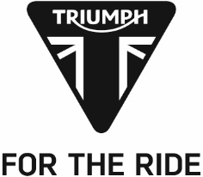
PRESS RELEASE

Triumph 765cc triple power sets new records and delivers thrilling Moto2™ 2019 season-opener in Qatar

Sunday’s Grand Prix of Qatar heralded a milestone as the first ever Triumph-powered Moto2™ race, and over 3,000km of full-on racing action at the dawn of a thrilling new era of the Moto2™ championship. An incredibly close and action packed inaugural race, kicked off with an incredible noise from the full grid of 32 Triumph 765cc triples, and ended with a photo finish of just 0.026 seconds.
In the debut weekend of the new era of Triumph engine supply to Moto2™ every Moto2™ record up for grabs in Qatar was redefined thanks to Triumph power:
- New Pole Position Record - Marcel Schrotter with a 1m 58.585
- Highest top speed - Alex Marquez set the at 294.4km/h
- Circuit Best lap - Race-winner Lorenzo Baldassarri
- Race Lap Record - Thomas Luthi
With Italian Lorenzo Baldassarri leading the field right from the start, the gap never reached much more than half a second despite in the closing laps coming under intense pressure from team mate duo Schrotter and Luthi.
Schrotter meanwhile came under pressure from Remy Gardner leading to an even closer finish – whilst Luthi trailed Baldassarri by just 0.026s at the line, the final step of the podium was clinched by Schrotter by a remarkable 0.002seconds.
Steve Sargent, Triumph’s Chief Product Officer, presented a one-of-a-kind Triumph special factory trophy to Lorenzo Baldassarri as the inaugural winner on a Triumph-powered Moto2™ race motorcycle. Steve Sargent said: “When we decided to come into Moto2™ we wanted to provide an engine that gave exciting and close racing and they don’t come much closer than the finish in Qatar. The teams and riders have all been very complementary about the Triumph engine and they believe there is more to come as they get used to the power and torque of the 765. It should be a great season.”
The Triumph Moto2™ 765cc race engine is a development of the class-leading Street Triple RS 765cc road motorcycle and produces more than 140ps and the same visceral soundtrack.
Watch out for more thrilling, hard-fought action, as Moto2™ racing moves to Argentina on 31st March.
#PoweredByTriumph #TriumphOfficial
ENDS
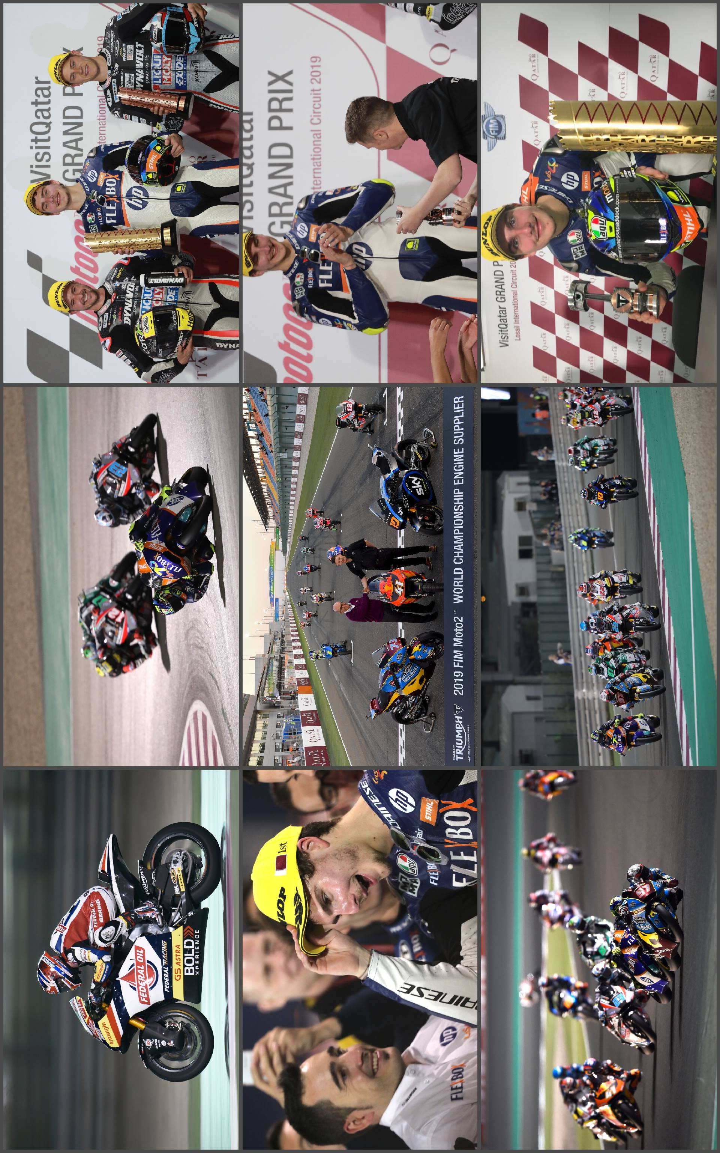

Notes to Editors
About Triumph
- The Triumph Moto2™ 765cc race engine is a development of the class-leading Street Triple RS 765cc road motorcycle and producing more than 140ps and the same visceral soundtrack.
- First established in 1902, Triumph Motorcycles celebrated 110 years of motorcycle manufacture in 2012. For more than two decades, Triumph Motorcycles has been based in Hinckley, Leicestershire, and has produced iconic bikes that perfectly blend authentic design, character, charisma and performance.

- Building around 65,000 bikes per year, Triumph is the largest British motorcycle manufacturer and has around 620 dealers across the world.

- This focus, innovation and engineering passion has today created a broad range of bikes suited to all motorcycle riders, including the iconic new Scrambler 1200, epic Speed Triple, the game changing all new Street Triple 765, the class defining Tiger 800, transcontinental Tiger 1200, iconic Triumph Bonneville family including the stunning Speed Twin, Bonneville Bobber, legendary Thruxton, accessible Street Twin, Street Scramble and iconic Bonneville T120 and T100, plus an exciting and accessible A2 range of Triumph motorcycles

- Triumph currently employs around 2,000 personnel worldwide and has subsidiary operations in the UK, North America, France, Germany, Spain, Italy, Japan, Sweden (Scandinavia), Benelux, Brazil, India and Thailand as well as a network of independent distributors. Triumph has manufacturing facilities in Hinckley, Leicestershire, and Thailand plus CKD facilities in Brazil and India.

- The Triumph Bonneville, famously named to celebrate Triumph’s 1956 land speed record on the Bonneville Salt Flats in Utah, USA, was the original British superbike and a race-winner straight out of the crate. Chosen by famous motorcyclists of the past for its legendary handling, style, and character. It’s that handling, character and style, married to modern rider-focused technology that makes the new Bonneville family THE authentic modern classic choice today.

- Triumph has a glorious racing history, competing in and winning races in almost every class and field of motorcycle sporting achievement. From winning the second ever Isle of Man TT in 1908, through to 1960s road and track domination in Europe and America, right up to contemporary racing achievements with the 675cc Triumph triple powered 2014 Daytona 200 win, the 2014 Isle of Man Supersports TT, 2014 and 2015 British Supersports titles and World SuperSport racing. And now with the new generation of 765cc triple engine powering the 2019 Moto2™ championship, Triumph’s racing legend continues.

